**How to change the WIFI name and WIFI password**

Product line: Wireless Model number: F3

The cause of the change WIFI name and wireless password is to protect the wireless network. This article will guide you how to change the wifi name and wireless password.

**Part 1**: Login the homepage of the router

**Part 2**: Change the SSID and wireless password

**Part 3**: Reboot the router



Open a browser then type **192.168.0.1** in the **Address bar**, click on **Enter**.

C:\Users\Jane Lee\Desktop\N301做FAQ\browser.PNG



**1** Type the **Password** as admin in the bars to login the setting page.

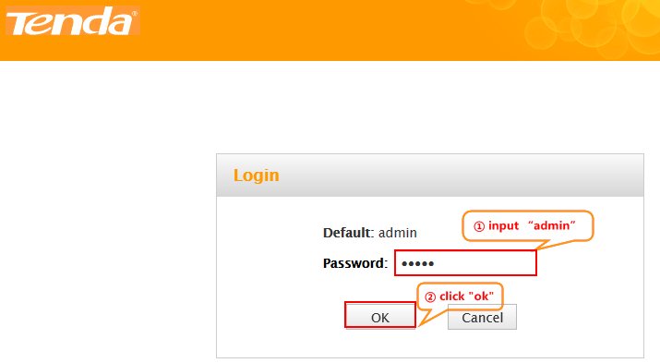

**2** Click on **Advanced** on the home page to login the advanced setting page.

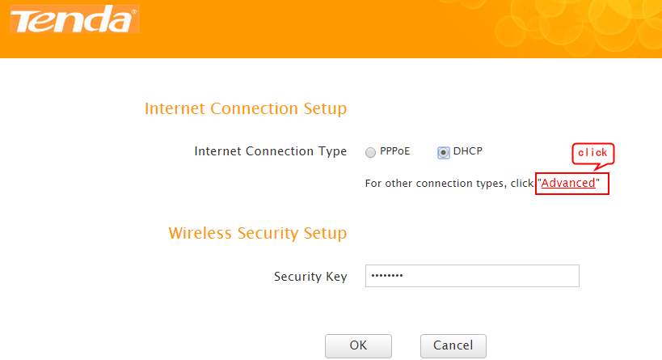

**3** Click on **Wireless**, then click on **Wireless Basic Settings** and making sure that wireless is **Enable**. Making sure the **SSID Broadcast** was checked, otherwise the wireless signal will not be found in your wireless bar of your computer. Also you can change the **Primary SSID** as you want. Then open the **drop down** menu of the **802.11 mode** optionand choose the mode as **11b/g/n mixed mode**. On this page you can choose the **Channel** and the **Extension Channel** will be selected automatically after choosing the **Channel**. Then let the other settings as defaulted, then click on **Save** to save the settings.

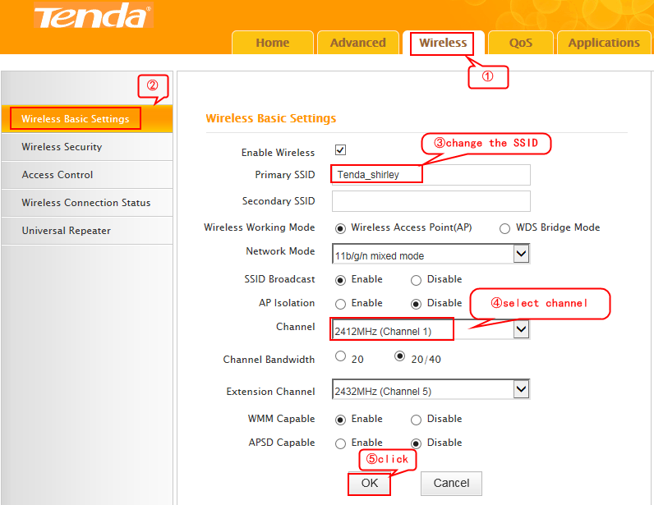

Note:

The **Channel 1, Channel 6** and **Channel 11**are recommended, since they are idle.

**4** Click on **Wireless**, then click on **Wireless Security** and choose the **Security mode** as **WPA-PSK**,and then open the drop down menu of the **WPA Algorithms** option then select the type as **AES** and set a **Security Key** as you want.At last, let the other options as defaulted and hit on the **Save** buttonto save the settings.

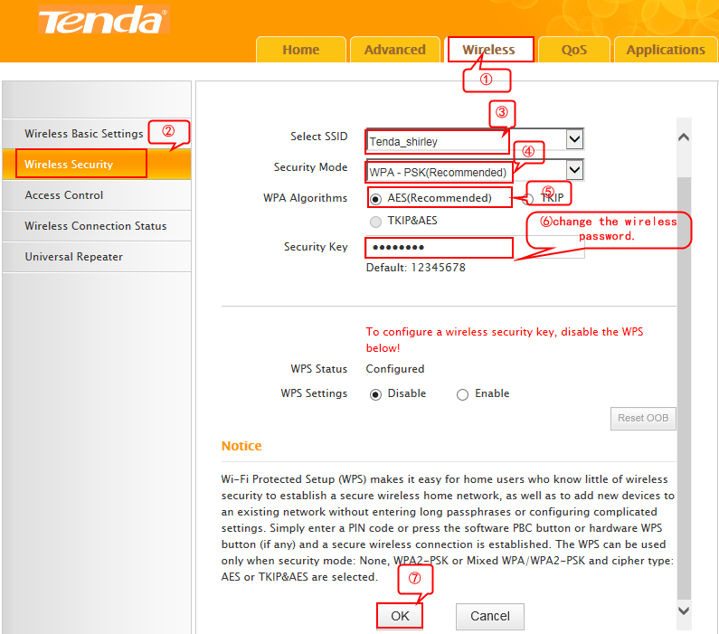

**Note**: **Security Key** should be at least **8** characters.

Reboot the router

Part 3

Click on **Tools**, and then choose the **Reboot** option on the left of the page, then hit on the **Reboot the router** to reboot the router.

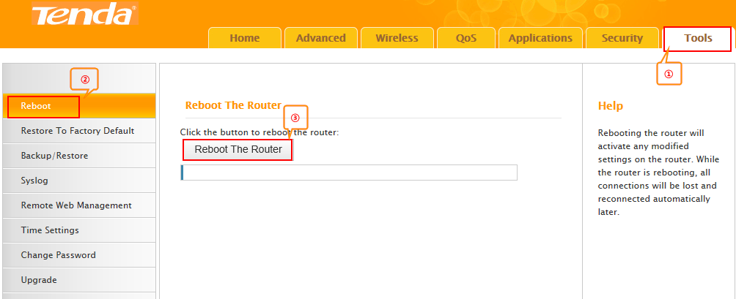  
Now you can use your laptop to search the new SSID and enter the new password to connect to it.